MOBIL APP DEVELOPMENET LAB

WEEK 2: Create “Say Hello” App

**THESE STEPS ARE ONLY FOR REFERENCE IN THE LAB……**

**FOR OBSERVATION AND MANUAL YOU NEED TO WRITE THE ACTIVITY_MAIN.XML FILE AND MAINACTIVITY.JAVA FILE AND THE EXECUTED OUTPUT**

Procedure:

Step 1: Open Android Studio

Step 2: In the main Welcome to Android Studio window, click New Project

Step 3: choose Empty views Activity

Step 4: Enter Project Details Enter Name (week2) ◊ Accept Default Package Name ◊ Choose Save Location ◊ Select Language ◊ Select Minimum SDK (API 24: Android 7.0 – Nougat) ◊ Click Finish Button

Open **activity_main.xml** (complete xml file with changes is shown below)

* Select Design View
* Add Widgets from pallet – EditText(plain text), TextView and Button
* Set the constraints by dragging all the widgets to the all four edges to form a zigzg pattern

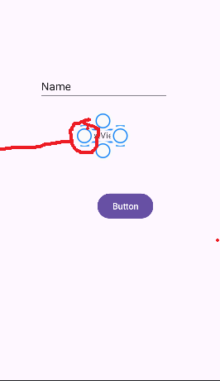 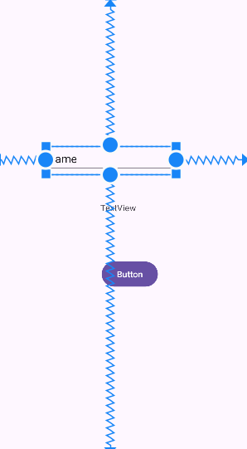

* Add Attribute Data Widget id Other Attributes
* **EditText** editTextName id="@+id/editTextName" hint="Enter Name" inputType="text"
* **TextView** textViewName id="@+id/textViewName" text="Hi"
* **Button** btnSubmit id="@+id/btnSubmit" layout_marginTop="8dp" onClick="SayHello" text="Say Hello"

# activity_main.xml

<?xml version="1.0" encoding="utf-8"?>  
<androidx.constraintlayout.widget.ConstraintLayout xmlns:android="http://schemas.android.com/apk/res/android"  
 xmlns:app="http://schemas.android.com/apk/res-auto"  
 xmlns:tools="http://schemas.android.com/tools"  
 android:layout_width="match_parent"  
 android:layout_height="match_parent"  
 tools:context=".MainActivity">  
  
 <Button  
 android:id="@+id/btnSubmit"  
 android:layout_width="wrap_content"  
 android:layout_height="wrap_content"  
 android:text="Say Hello"  
 android:onClick="SayHello"   
 app:layout_constraintBottom_toBottomOf="parent"  
 app:layout_constraintEnd_toEndOf="parent"  
 app:layout_constraintHorizontal_bias="0.553"  
 app:layout_constraintStart_toStartOf="parent"  
 app:layout_constraintTop_toTopOf="parent"  
 app:layout_constraintVertical_bias="0.623" />  
  
 <EditText  
 android:id="@+id/editTextName"  
 android:layout_width="wrap_content"  
 android:layout_height="wrap_content"  
 android:ems="10"  
 android:inputType="text"  
 android:hint="Enter Name"  
 app:layout_constraintBottom_toBottomOf="parent"  
 app:layout_constraintEnd_toEndOf="parent"  
 app:layout_constraintHorizontal_bias="0.412"  
 app:layout_constraintStart_toStartOf="parent"  
 app:layout_constraintTop_toTopOf="parent"  
 app:layout_constraintVertical_bias="0.342" />  
  
 <TextView  
 android:id="@+id/textViewName"  
 android:layout_width="wrap_content"  
 android:layout_height="wrap_content"  
 android:text="Hi"  
 app:layout_constraintBottom_toBottomOf="parent"  
 app:layout_constraintEnd_toEndOf="parent"  
 app:layout_constraintStart_toStartOf="parent"  
 app:layout_constraintTop_toTopOf="parent" />  
  
</androidx.constraintlayout.widget.ConstraintLayout>

Open MainActivity.java and write Code

package com.example.week2;  
  
import androidx.appcompat.app.AppCompatActivity;  
  
import android.os.Bundle;  
import android.view.View;  
import android.widget.TextView;  
import android.widget.EditText;  
  
  
public class MainActivity extends AppCompatActivity {  
 TextView textViewName;  
 EditText editTextName;  
  
  
 @Override  
 protected void onCreate(Bundle savedInstanceState) {  
 super.onCreate(savedInstanceState);  
 setContentView(R.layout.*activity_main*);  
 }  
 public void SayHello(View view) {  
 editTextName = findViewById(R.id.*editTextName*); //EditText  
 textViewName = findViewById(R.id.*textViewName*); //TextView  
 textViewName.setText(“Hi ”+editTextName.getText());  
 }  
}

Run the virtual device from the device manager (creation of a virtual device is given in week 1 word document)

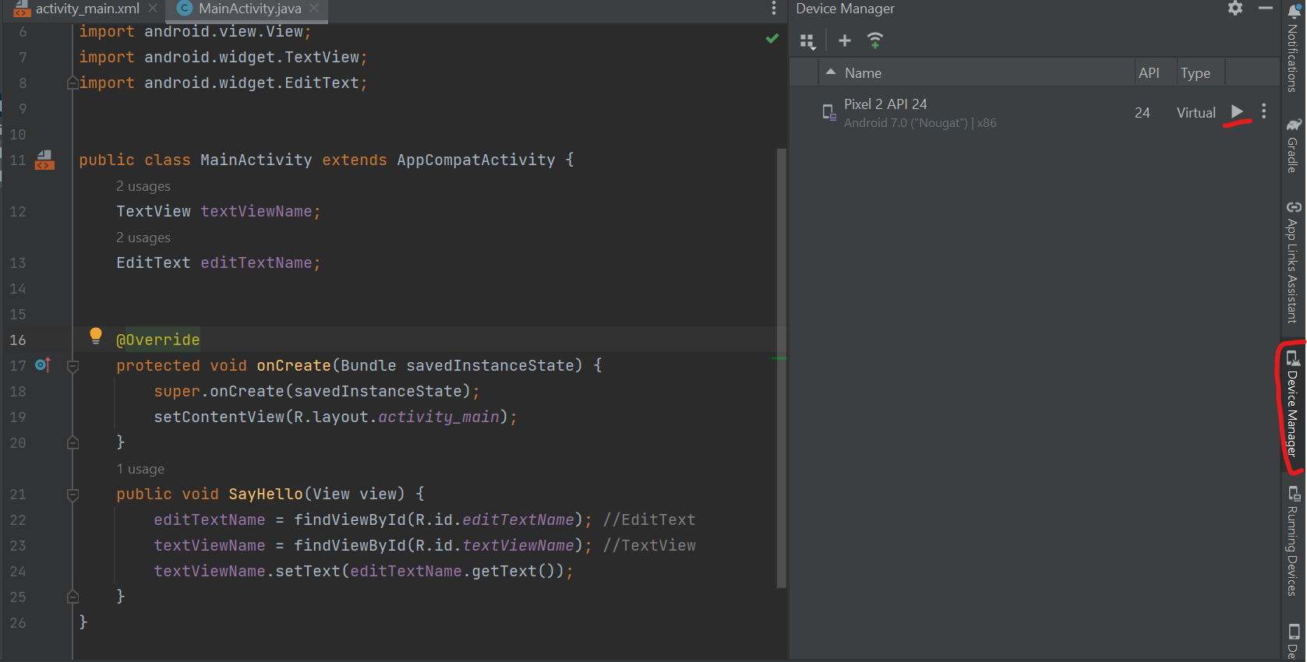

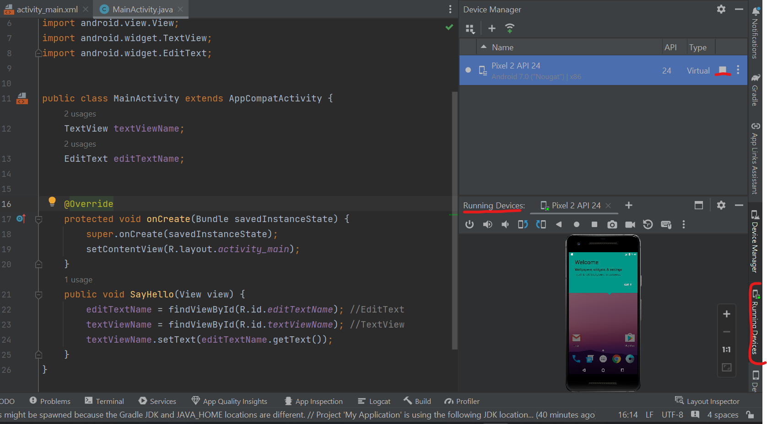

Now run the app

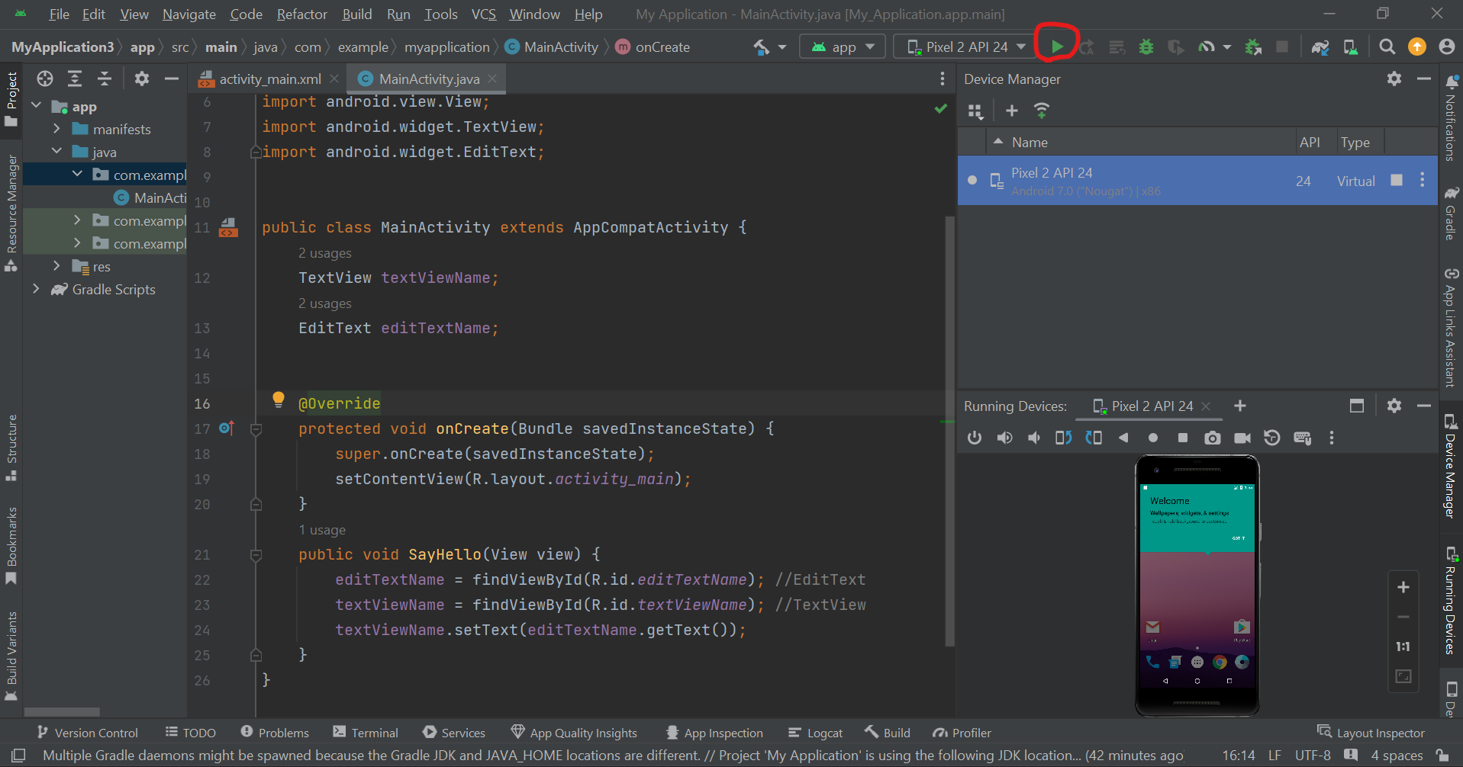

Output will be generated in the virtual device

Type the name in the text box and click the button…. You will get the name in the edit text below

